

Project overview

This is an online platform for buying products such as phones, laptops, and smart wear. The platform makes contracts with the three big brands in electronics, like Apple, Oppo, and Samsung. Each brand has a page on the platform to sell their products. Admins can only access the dashboard. This dashboard is designed to view the statistics of each product. This dashboard helps the organization increase performance and make better decisions.

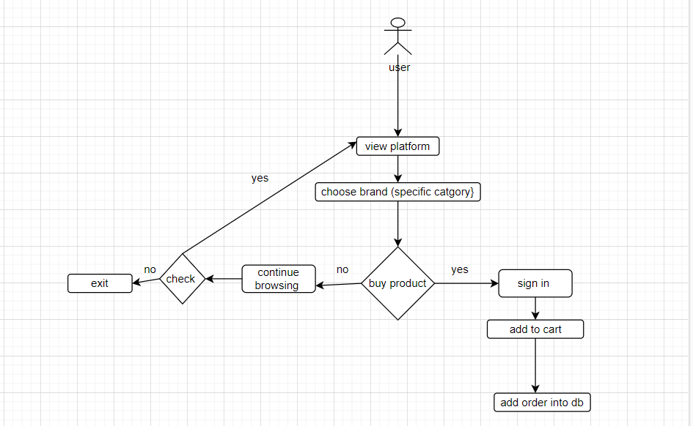

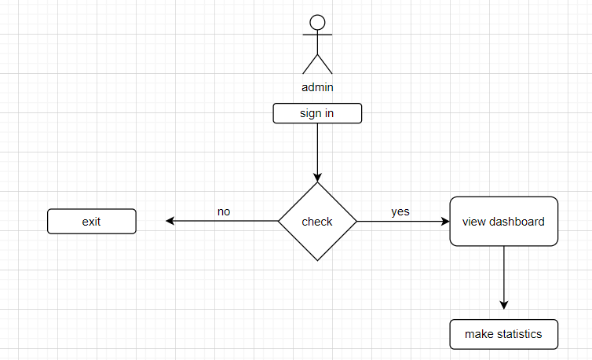

# Tools

# Frontend :

1. Html
2. Css
3. JavaScript

# Backend:

1. Php

# Database:

1. Sql DB